DBMS-LAB 4

RAILWAY RESERVATION

Name: Ishita Bharadwaj Srn: PES1UG20CS648

Section: K Roll no: 43

Task-1:

1. Insert the shared data into the respective tables using the appropriate insert query.

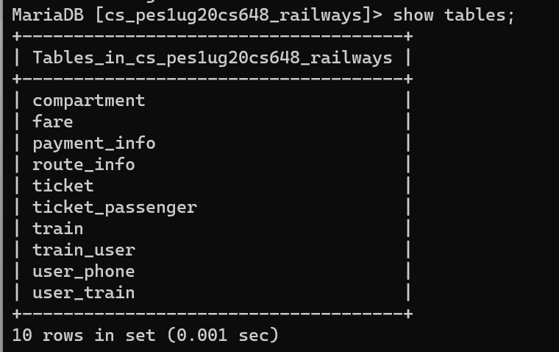

1. Calculate and update the age attribute in User Table.

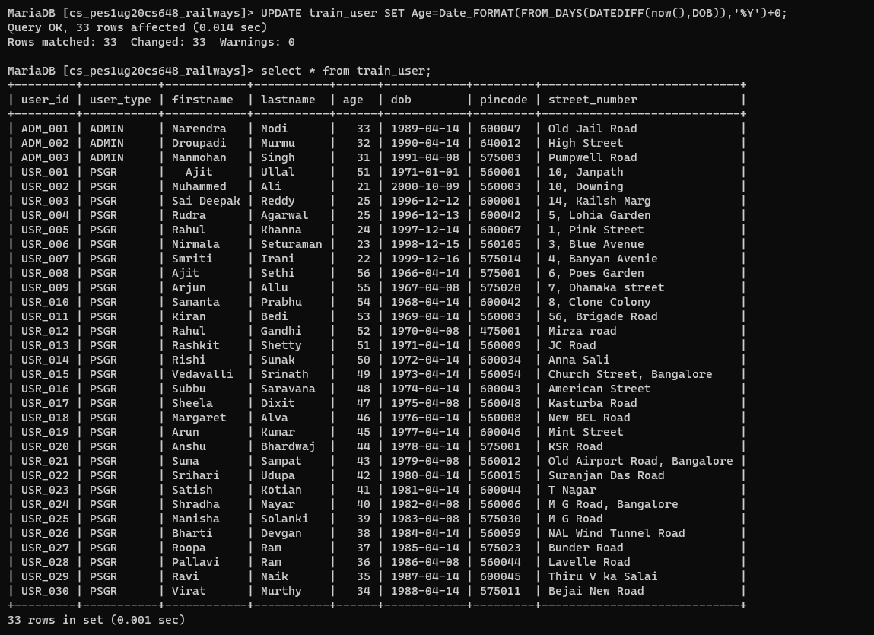

1. Display all the route information whose distance falls in a range from 70 to 150 km.

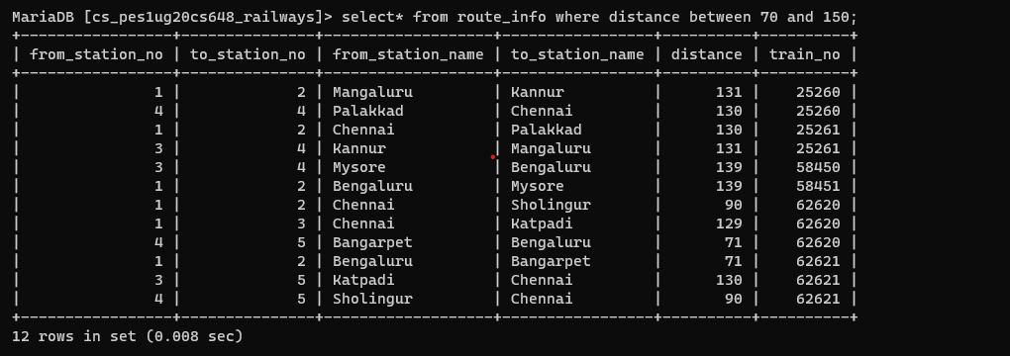

1. Display the train route information which is run between Chennai to Sholingur

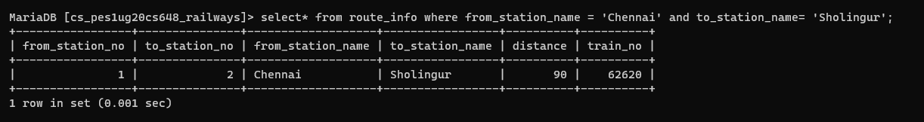

1. Display the train details whose type is not mail.

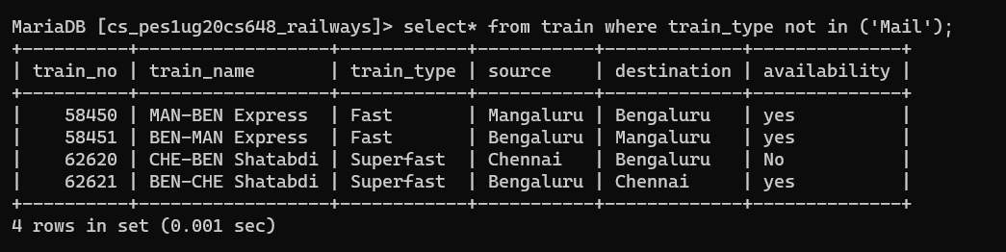

1. Display the train name which goes to Chennai from Bangalore.

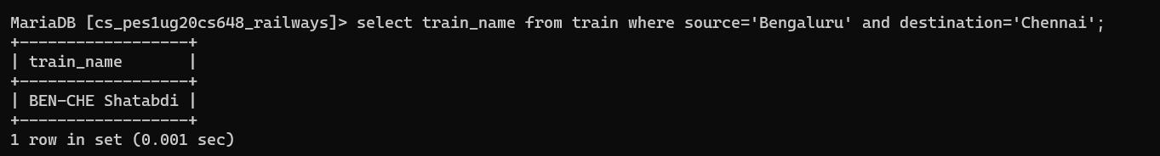

1. Display the list of trains starting from Chennai after 8:00.

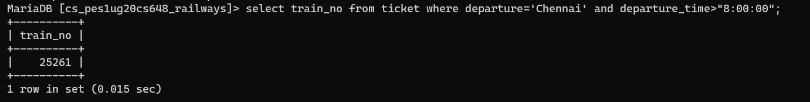

1. Display the list of users who are born between 1980 to 1990.

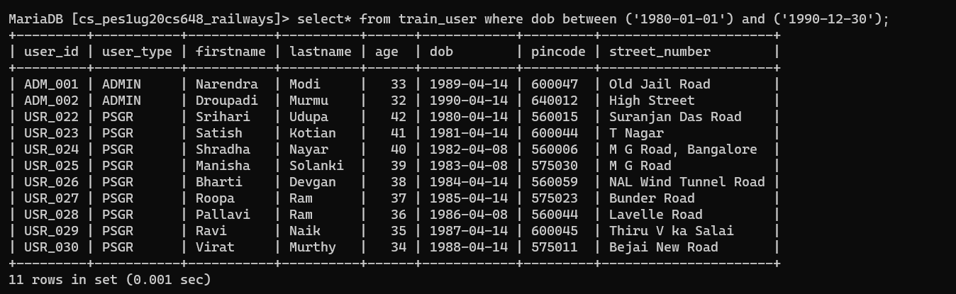

1. Display the train users whose name starts with the letter ‘S’.

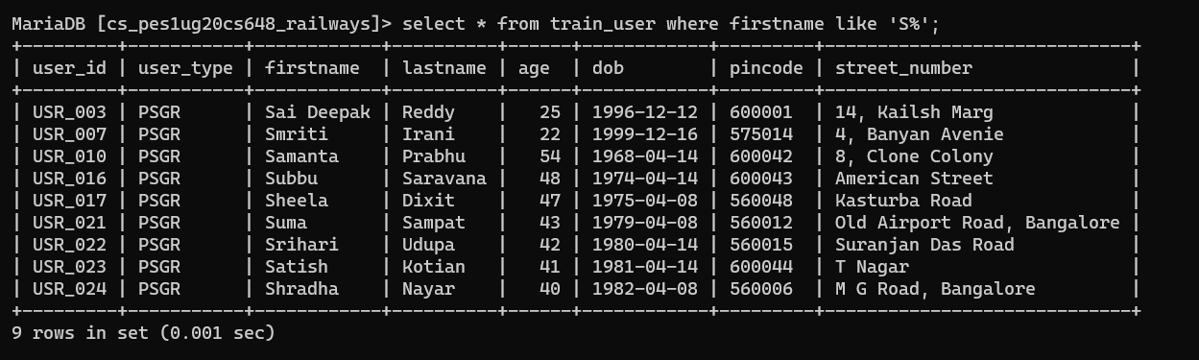

1. Find the availability of I Class compartment of the train number 62621.

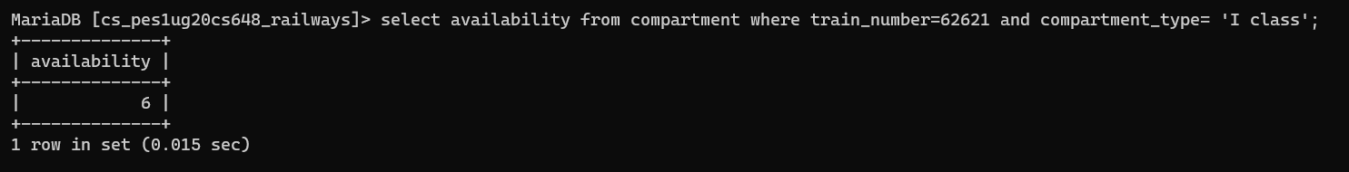

1. Find the PNR and Transaction ID of the users who made payment via Union Bank.

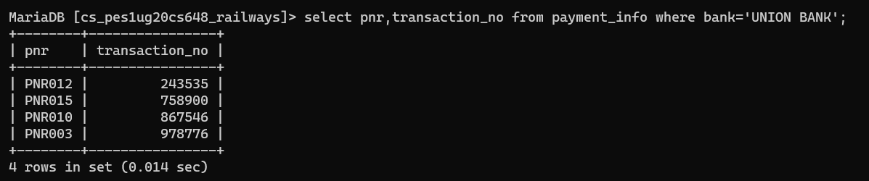

Task-1:

1. Grant privileges on different tables to users and observe the effect.

Create users

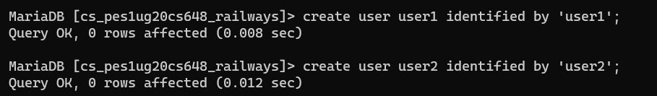

Checking if database can be accessed

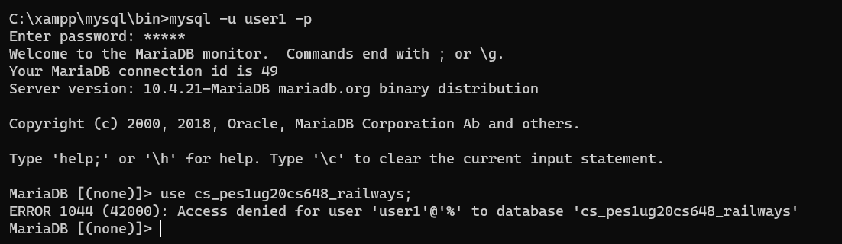

Granting select privilege on train table and create privilege on compartment table

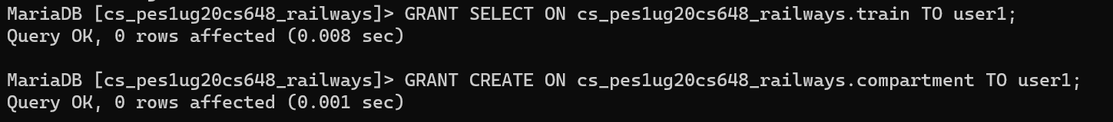

Show the grants for the particular user

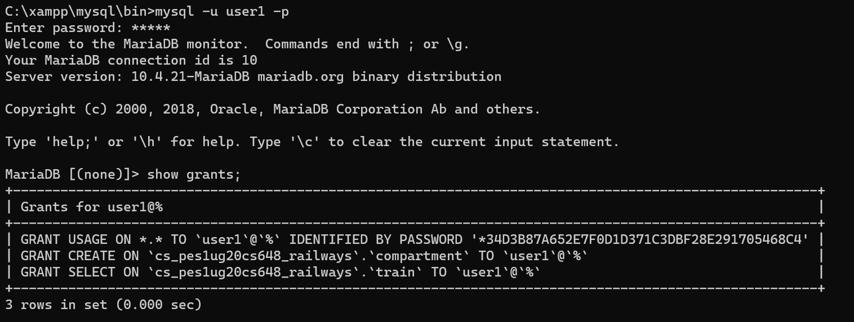

Select operation is working on train table

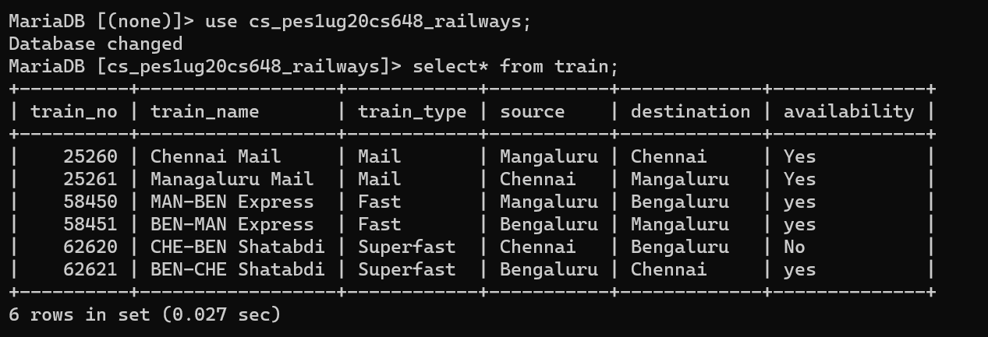

Select command does not work on compartment table



1. Revoke UPDATE & DELETE privileges on any tables and observe the effect if any

deletion/updation is performed.

Granting update and delete privileges on compartment table

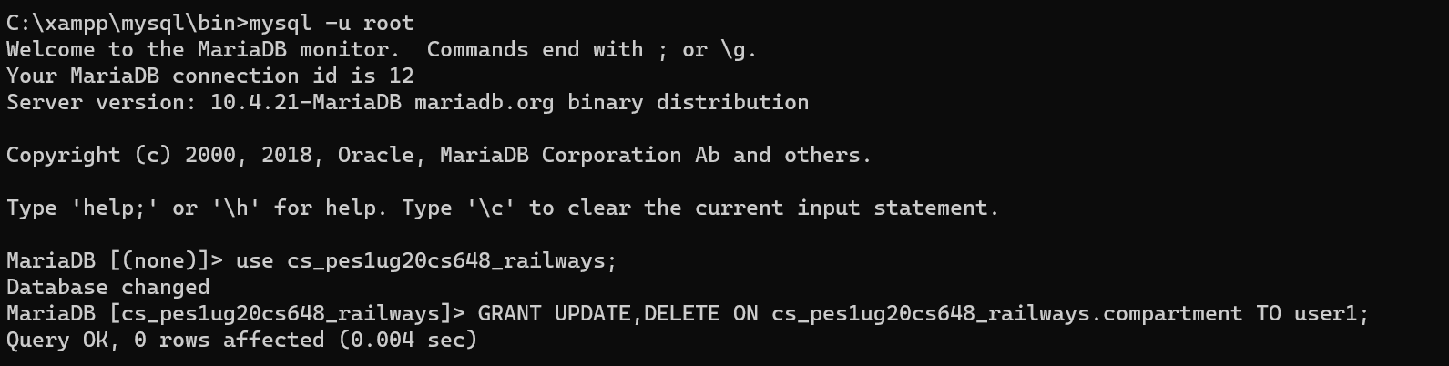

Show grants

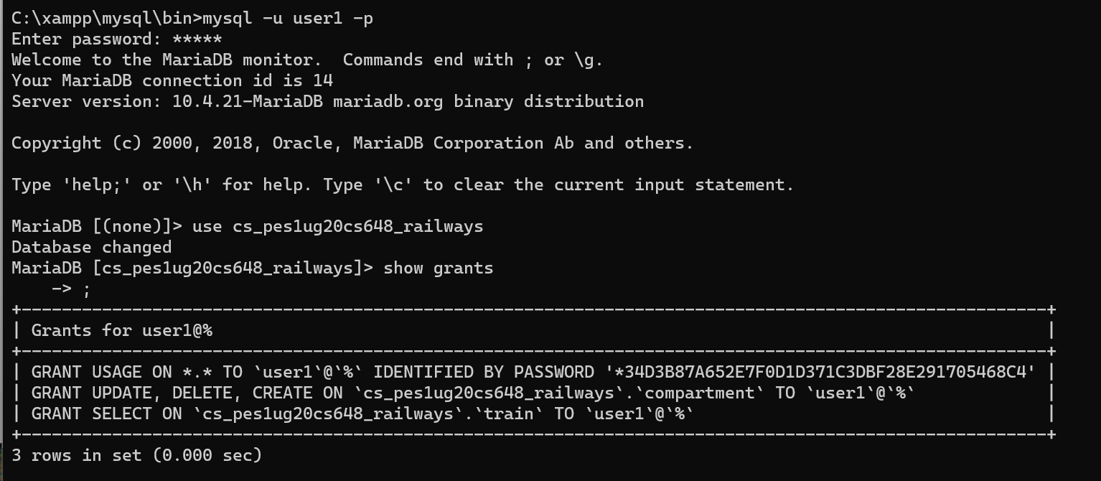

Table before updation of first value



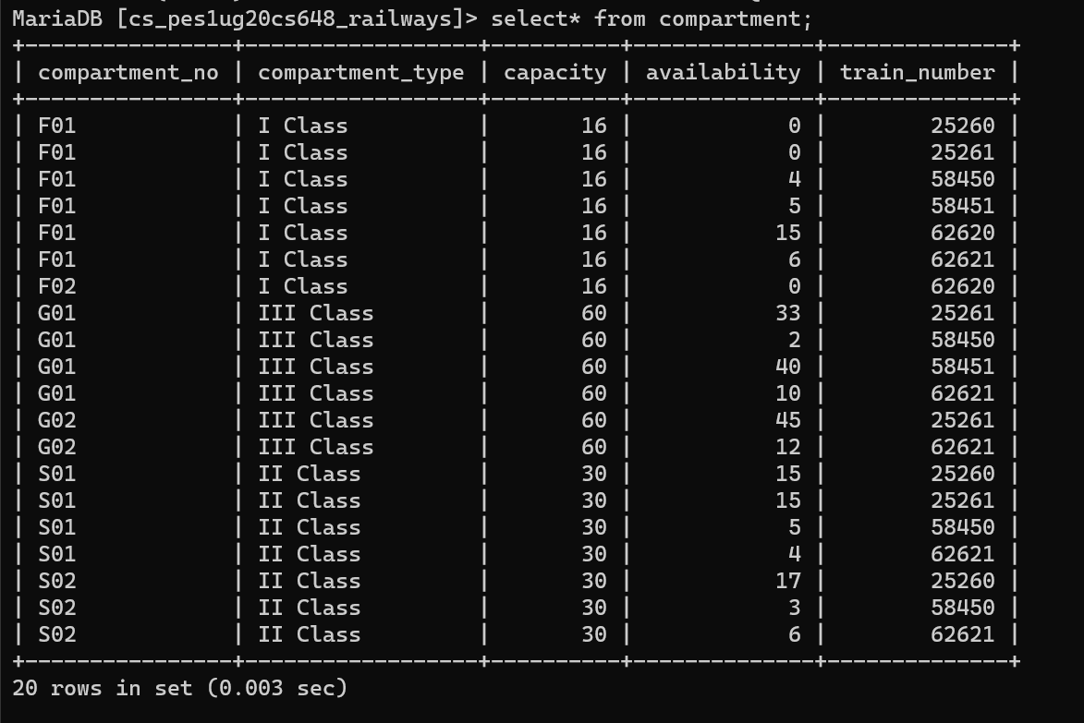

Table after updation of value

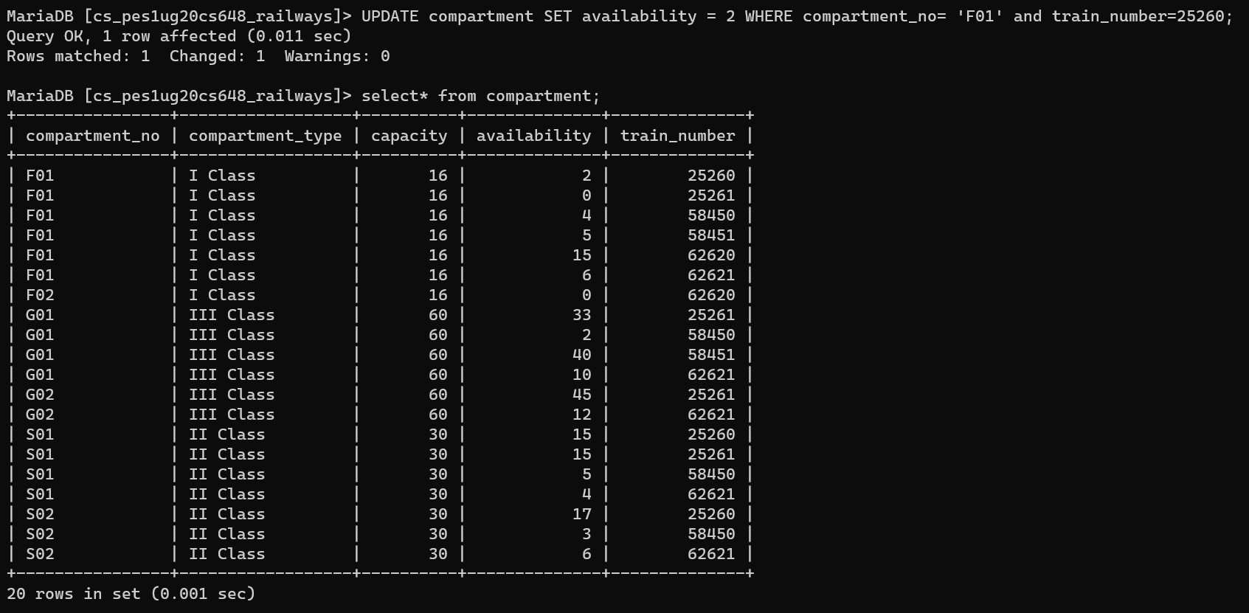

Revoking UPDATE and DELETE from table



Show grants and UPDATE does not work

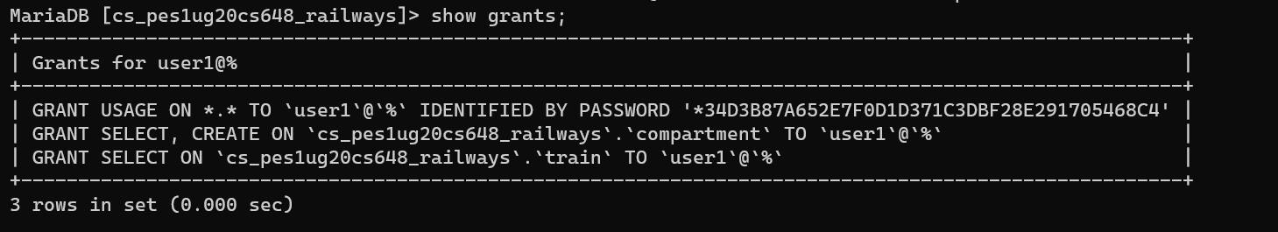



1. Create different save points and perform some insert/update/delete operations. Observe the effect of commit & rollback operations and release any created savepoints.

Started a transaction and added savepoints and rollback and released savepoints

